Requirements Management Enablement Guidance

Contents

1.0 Introduction 2
2.0 Overview 3
2.1 General guidelines \ expectations 3
2.2 Key assumptions 3
3.0 Decision criteria 4
3.1 Small project meeting criteria for using Lite SDA 4
3.2 Major project meeting criteria for using Standard SDA option (waterfall or iterative) 4
4.0 Supplemental guidance 7
4.1 Iterative projects 7
4.2 Waterfall projects 8
5.0 References 9

1.0 Introduction
Requirements management (RM) is the business analysis sub-process which establishes and maintains the “agreement” with the customer on the requirements as embedded in the written requirement specifications and models. Prior to determining the approach to managing requirements, the requirements baseline is developed using the business analysis sub-process to develop requirements. The product must possess a set of quality baseline requirements specified in a hierarchical format (business, user and functional) to effectively manage requirements for the life of the product.

Several key principles for requirements management are common in the industry. Those principles include:
- Establishing an agreement (written as the specified requirements) with the customer on the product’s requirements and project work is based on this agreement
- Requirements agreements are maintained throughout the project lifecycle and for the life of the product
- Requirement hierarchy demonstrates parent-child relationships to ensure alignment to the product vision and to avoid building unnecessary features
- Requirement traceability links requirements to other requirements, to the design and code elements (implementation of requirements) and to the tests (verification of requirements)
The above stated key principles are agnostic to using a technology platform to enable requirements management. It is widely accepted within the industry that using a tool to compensate for lack of process, discipline, or understanding of requirements engineering is counterproductive and costly. This guidance is intended to provide decision criteria for determining the appropriate RM enablement solution based on project scenarios defined in the IT Services organization.

2.0 Overview
The purpose of this guidance is to provide the business analyst with available options for using an enabler to manage requirements. The guidance is established for each Service Delivery Approach (SDA) as defined in the IT Services methods. For each SDA, a set of decision criteria, considerations and references have been identified to guide the decision for which enabler is appropriate to support RM activities.

This guidance has been developed as a short-term, tactical solution until a more strategic solution can be developed. Significant weight has been given to licensing implications and change management in developing this recommendation.

2.1 General guidelines \ expectations
The guidance is meant to advise business analysts and their supporting project teams, regarding which enabler is appropriate to support the BA requirements management sub-process. It assumes the reader has thorough knowledge of the business analysis process and how to develop and manage quality requirements for a product. General RM guidelines include:

- Requirements management is the responsibility of the business analyst role
- Requirements documentation using the existing templates for Vision and Scope, Requirements Specification, and Supplemental Requirements Specification is expected to be maintained for all projects in IT Services, regardless of size
- Adherence to the principles of the business analysis process is essential to effectively leverage a RM enabler
- When a project is part of a larger program, the project should align to the RM solution used by that program
The guidance has been socialized and approved by an appointed steering group comprised of extended leadership team members. Deviation from the recommendations is discouraged and concerns should be directed to the appropriate Service Delivery lead.

2.2 Key assumptions
The guidance is meant to advise business analysts regarding which enabler is appropriate to support the BA requirements management sub-process. It assumes the reader has thorough knowledge of the business analysis process and how to develop and manage quality requirements for a product. General RM guidelines include:

- The team is versed in IT Services methods and experienced using the selected RM enabler
- The development team uses Microsoft TFS as the application build process enabling platform and manual effort may be required to import requirements
- The testing team uses HP ALM as the validation and testing process enabling platform and manual effort may be required to import requirements
- The standard requirements document templates are the source record for requirements regardless of enabling tools that are in use

3.0 Decision criteria

3.1 Small project meeting criteria for using Lite SDA
The table below “Requirements Management (RM) Enablement for Lite SDA” should be used to determine which RM enablement solution is fit for purpose. Please refer to CLEAR (Capability Lead Execution & Results) for information about Service Delivery Approaches (SDAs).

Requirements Management (RM) Enablement for Lite SDA
Enablement solution | Considerations | Reference
Manage requirements using legacy format | ►Requirement artefacts should be maintained | ►N/A
Manage requirements using the standard template | ►Enhancement specification will be used to document enhancements | ►Enhancement specification is available in CLEAR

3.2 Major project meeting criteria for using Standard SDA option (waterfall or iterative)

The table below “Requirements Management (RM) Enablement for Standard SDAs” should be used to determine which RM enablement solution is fit for purpose. It provides considerations and references for each enablement solution. Please refer to CLEAR (Capability Lead Execution & Results) for information about Service Delivery Approaches (SDAs).

Requirements Management (RM) Enablement for Standard SDAs
Enablement solution | Considerations | Reference
Manage requirements using the BA standard templates combined with TFS and HP ALM for managing traceability | ►►Consider for projects where TFS is in use by AEs and HP ALM is in use by QA Teams. This is the enablement solution expected to be used in the majority of projects.  ►On a team of multiple business analysts, one may be assigned to work with AEs and QA to manage traceability within TFS and HP ALM, respectively  ►BA’s specify requirements per standard process and templates  ►AEs will be responsible for transferring business and user requirements to TFS and QA will be responsible for transferring business and user requirements to HP ALM.  ►Risk involved in keeping requirements maintained across documents and these tools  ►►Traceability of development and test cases to requirements and between requirements will be available and reportable from TFS and HP ALM, respectively.  ►All requirement artefacts and documentation should reside in the current IT Services standard project repository | ►Refer to CLEAR for BA process documentation  ►See Figures 1, 2 and 3 below in Section 5.0 References  ►For additional guidance on TFS or HP ALM, please refer to the TFS Requirements Management Guidance or HP ALM Requirements Management Guidance documents which can be found in CLEAR by selecting the Enabler tab> Process drop down = Application Build> Enabler type = Guidance or Process drop down = Validation & Testing> Enabler type = Guidance, respectively
Manage requirements using only the BA standard templates | ► Consider for projects with few requirements which do not otherwise meet the criteria for Lite SDA.  ►On a team of multiple business analysts, one may be assigned to manage traceability  ►BA’s specify and manage requirements per standard process and templates  ►► Manual effort required later should the baseline requirements need migrating to technology options (e.g. TFS/HP ALM)  ►►No support for automated traceability  ►No reporting capability  ►AEs and QA team will not have automated support for requirements linkage  ►All requirement artefacts and documentation should reside in the current IT Services standard project repository | ►Refer to CLEAR for BA process documentation
Manage requirements using the BA standard templates combined with HP ALM for managing traceability | ►Consider for projects where there is no software engineering in TFS and HP ALM is in use by QA Teams  ►On a team of multiple business analysts, one may be assigned to work with QA to manage traceability within HP ALM  ►BA’s specify requirements per standard process and templates  ►QA will be responsible for transferring business and user requirements to HP ALM  ►Risk involved in keeping requirements maintained across documents and in the HP ALM tool  ►►Traceability of test cases to requirements and between requirements will be available from HP ALM  ►►Automated reporting related to Requirements Coverage and Traceability will be available in HP ALM  ►All requirement artefacts and documentation should reside in the current IT Services standard project repository | ►Refer to CLEAR for BA process documentation  ►For additional guidance on HP ALM, please refer to the HP ALM Requirements Management Guidance document which can be found in CLEAR by selecting the Enabler tab> Process drop down = Validation & Testing> Enabler type = Guidance
Manage legacy baseline requirements using existing format | ►► Consider for projects with requirements in legacy format, where migration to the standard format is unreasonable due to cost or time.  Requirement artefacts should be maintained  ►►Reverse engineering to build traceability should only be done if situation warrants the effort  ►►Manual effort will be required later should the requirements need migrating to technology options (e.g. TFS/ALM/other)  ►Provides no reporting capability  ►►All requirement artefacts and documentation should reside in the current IT Services standard project repository | ► N/A

4.0 Supplemental guidance
The list below is to provide best practices guidance for managing requirements when working on either waterfall projects or iterative projects:

- Do not include detailed requirements in the tools-- just include a link to the source document -- this way the requirement in the tool doesn't need to change every time the detail of the requirement changes and will reduce the risk of having the tools get out of sync with the source documents. If the team (AE or QA) chooses to add the detail to the tool, then it is their responsibility to ensure it is properly maintained
- It is highly recommended that requirements be entered into enabling tools only once they are baselined. This will reduce the number of changes that may be required and risk of requirements becoming out of sync with the source documentation.
- In some situations, QA Teams and/or AEs may start working with requirements before all requirements have been officially approved and baselined. Both AE’s and QA Teams should exercise caution when considering when to enter the requirements in their respective tool. Doing so before the requirements are baselined may result in rework for those roles. If there is a valid reason to enter requirements in the tools prior to baseline, this necessitates a more rigorous review once they are baselined to ensure requirements in both tools are in sync.
- It is the responsibility of the BA to manage and communicate changes to requirements that have been baselined. To ensure consistency in what is represented in the tools that are in use, it is recommended that a joint review session be held with the BA, AE and QA resources to ensure these are reflected properly.
- Large, more distributed teams will require more tooling support. Similarly, the more critical a project is as well as the greater the impact associated with a missed requirement, the more necessary it is to apply sufficient rigor to requirements management. In making a decision whether or not to use a tool to enable this process, these factors should be carefully weighed.
- The non-functional requirements included in the Supplemental Requirements Specification should continue to be specified and managed in that document. Generally, these requirements should not need to be uploaded to the tools, and they are not currently reflected in the Requirements Traceability Matrix.

4.1 Iterative projects
Additional best practices guidance for managing requirements when working on iterative projects:

- An iterative project results in constantly changing requirements (e.g. merged, split, etc.) with each iteration. Therefore, it is highly recommended to have a meeting/work session at the beginning of each iteration with the BA, QA and AE to walk-through what has changed in the user stories and have the AEs/QA Teams make their changes in the respective tools during the session.

- A traceability matrix should be generated from HP ALM and TFS at the start of each new iteration once the requirements have been baselined and entered into the respective tools. This should be reviewed/approved by the Lead BA.

4.2 Waterfall projects
Additional best practices guidance for managing requirements when working on waterfall projects:

- It is highly recommended that requirements not be entered into any tools prior to final baseline. Once the requirements have been baselined, it may be beneficial to hold a joint session with the BA, QA and AE resources for the express purpose of entering these requirements into the respective tools and reflecting the traceability between requirements within the tools.
- A traceability matrix should be generated from HP ALM tool and TFS as part of the Requirements Gate review and reviewed/approved by the Lead BA as soon as possible after the requirements have been baselined.

5.0 References
Figure 1 – Manage requirements using the BA standard templates combined with TFS and HP ALM for managing traceability

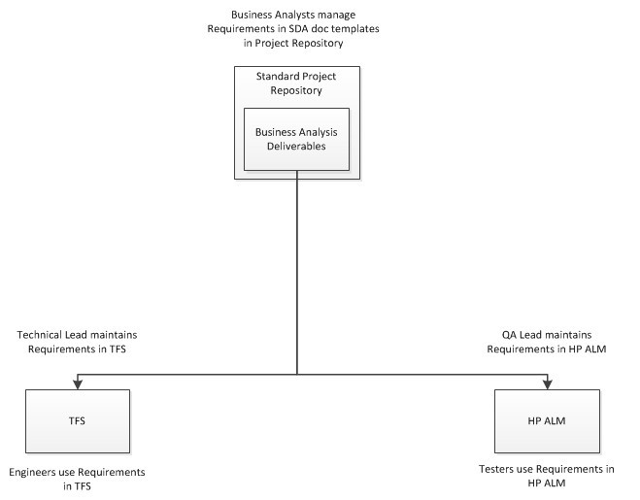

Figure 2 – Conceptual Overview of Requirements Management across the project disciplines
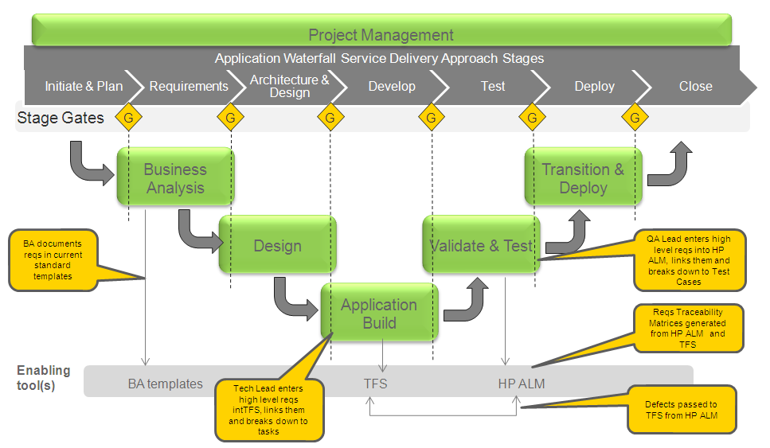

Figure 3 – Requirements Enablement RACI
